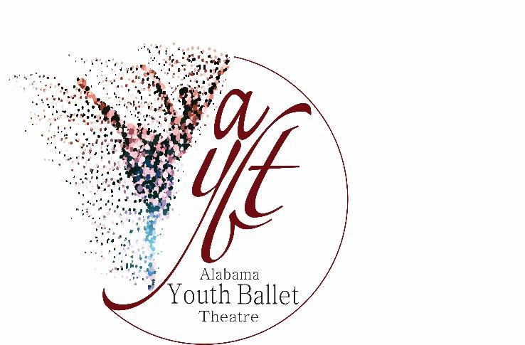

Alabama Youth Ballet Theatre
Performance Corporate and Business Sponsorships

Season Sponsor: A $3500 donation will provide a full-page ad, a logo and link on our home page, and acknowledgement in all print materials and announcements.

Show Sponsor: (Yuletide OR Fairytale) A $1000 donation will provide acknowledgement in all print materials, a logo and link on our home page, and announcements for the selected show.

Scene Sponsor: A $500 donation will provide an acknowledgment in the Program for the selected scene.

Soloist Sponsor: A $150 donation will provide an acknowledgement in the Program for the selected show and named soloist.

Corps de Ballet: A $25-$149 donation will provide acknowledgement in Programs.

We offer tickets to shows based on your sponsorship if requested. If you are interested in acquiring tickets please contact aybt@aybtheatre.org.

Alabama Youth Ballet Theatre 1405-D Weatherly Plaza SE Huntsville AL 35803 256-881-5930 aybt@aybtheatre.org
Alabama Youth Ballet Theatre is a 501 (c)3 Charitable Organization 2023/2024

Payment Options

By check: Checks can be made out to Alabama Youth Ballet Theatre or AYBT. They can be mailed to our address listed below:

Alabama Youth Ballet Theatre
1405-D Weatherly Plaza SE
Huntsville, AL 35803

By credit card: https://alabama-youth-ballet-theatre.square.site/
Please note…payments made online will show a higher amount to cover the convenience fee our online transaction partner receives.

Your program ad will be seen at three different shows during the 2023-2024 season (Nutcracker, Cinderella, and AYBT’s School Showcase) and reach an audience of up to 5,000 patrons. We are selling full, half, and quarter page ads for our season programs.
To thank you for your donations and support, we will add a link to your business on our website, www.aybtheatre.org for full-page and cover ads.

We will also provide you with a receipt for tax purposes. If you would like to sponsor an amount not listed, your ad will show at the closed amount. We welcome any donation and are grateful for your support. Any questions should be directed to aybt@aybtheatre.org

Thank you for supporting the arts in our community and making it possible for Alabama Youth Ballet Theatre to continue dancing!

