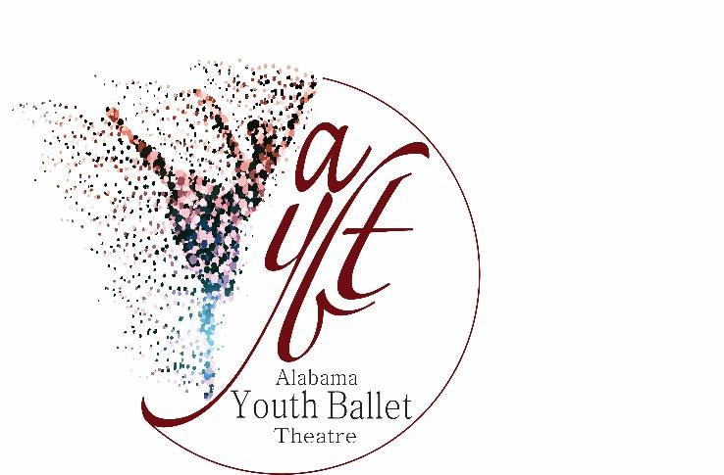

Alabama Youth Ballet Theatre
Performance Individual Sponsorships

Season Individual Sponsor: A $3500- $3500+ donation will provide your name acknowledgement in all print materials and announcements.

Show Individual Sponsor: (Yuletide OR Fairytale) A $1000-$3499 donation will provide your name acknowledgement in all print materials and announcements for the selected show.

Scene Individual Sponsor: A $500-$999 donation will provide your name acknowledgment in the Program for the selected scene.

Soloist Individual Sponsor: A $150-$499 donation will provide your name acknowledgement in the Program for the selected show and named soloist.

Corps de Ballet: A $25-$149 donation will provide your name acknowledgement in Programs.

Alabama Youth Ballet Theatre 1405-D Weatherly Plaza SE Huntsville AL 35803 256-881-5930 aybt@aybtheatre.org
Alabama Youth Ballet Theatre is a 501 (c)3 Charitable Organization 2023/2024

Payment Options

Paying by check: Checks can be made out to Alabama Youth Ballet Theatre or AYBT. They can be mailed to our address listed below:

Alabama Youth Ballet Theatre
1405-D Weatherly Plaza SE
Huntsville, AL 35803

Paying by credit card: This option is currently available only in-studio.

We will also provide you with a receipt for tax purposes. We welcome any donation and are grateful for your support. Any questions should be directed to aybt@aybtheatre.org

Thank you for supporting the arts in our community and making it possible for Alabama Youth Ballet Theatre to continue dancing!

